2015-NL-01-EN Robot painting
0 ---- | I: ---- | II: hard | III: medium | IV: medium

Answer Type: Interactive Mandatory for: none

Body

You are playing a computer game with the robot on a grid. The grid consists of 6 rows of 8 squares as shown on the picture below. The squares can only be white or colored.

You can instruct a robot to color (some of) these pixels. You can give three different instructions:

Color | Color the current square. If the square is already colored, the program terminates.
Right | The robot moves one square to the right. If it would walk of the grid it moves to the leftmost square of the same row.
Down | The robot moves one square down. If it would walk of the grid it moves to the top square of the same column

The robot starts in the square at the top left corner when the grid is completely white. The robot will keep repeating the set of instructions until it tries to color a square that has already been colored.

The following animated image shows what happens with the program that is shown.

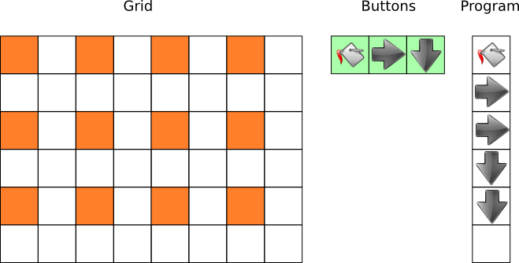

Question

Write a short program that will color all squares on the grid. Your program should fit in the program section.

Answer

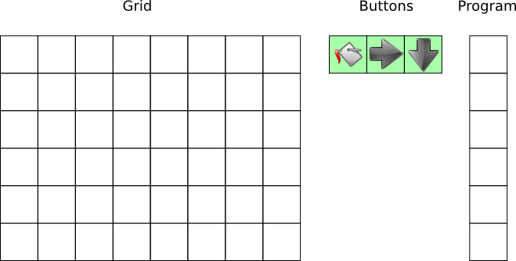

Interactive task. A reset- and a submit-button are needed. The program section can be extended to at most 10 commands.

Explanation

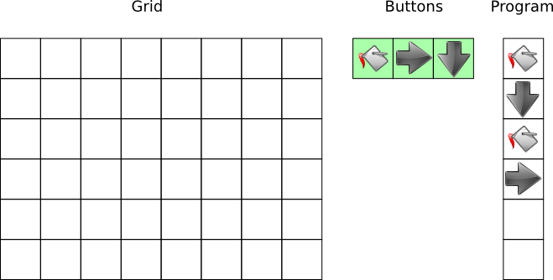

This is the shortest possible program. Note each program needs to contain at least one Color-command, otherwise it will not terminate.
A program of 1 step is not possible; you will color, and then it terminates.
A program of 2 steps can only contain one arrow, so it will form a line and terminate.
A program of 3 steps can contain two different arrows; then only half of the squares will be colored. If it contains two arrows of the same type, it will never leave the line, so it will not color all squares.

It's informatics

The task is about planning and programming a simple device.
The commands are repeated until a condition is met to terminate the program.

Because the grid wraps around, it is actual a torus, on which you can keep moving.

Keywords

Programming
command
repetition
grid

Websites

Internal Use

Wording

Comments

Willem van der Vegt, w.van.der.vegt@windesheim.nl 13-04-2015
New version at the Bebras Workshop. Kim changed the text, Adil worked the graphics.

Graphics
Home made and to be improved

Files

All additional files for this task (graphics, scripts, etc.)
2015-NL-01-EN.odt (this file)
2015-NL-01-question.png
2015-NL-01-ans.png
Add more

Authorship

Willem van der Vegt, NL, w.van.der.vegt@windesheim.nl

License

Copyright © 2014 Bebras – International Contest on Informatics and Computer Fluency. This work is licensed under a Creative Commons Attribution-NonCommercial-ShareAlike 3.0 Unported License (CC BY-NC-SA 3.0). Visit: http://creativecommons.org/licenses/by-sa-sa/3.0/

